Regional Capacity Building Workshop *for NWFPs in Eastern Europe, Central Asia and Caucasus*

Field Visit

10 October 2024 Thursday

08:00-09:00 Depart from Training Center for Kabaağaç Village, Seydikemer, Muğla, Türkiye (21 km)

09:00-11:00 Visiting Truffle Orchards and Greenhouses

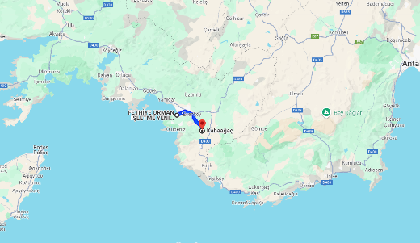

11:00-12:00 Depart to Yanıklar Location- (37 km)

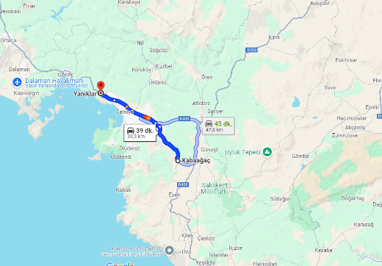

12:00-14:00 Lunch at the Yanıklar Forest Fire Control Location

14:00-16:00 Depart to Dikmen Honey Forest (29 km) Behaves and Beekeepers on the way.

*Marchalina hellenica* site around Karacaören, Fethiye/Muğla

17:00-19:00 Dinner -Cultural Event in Karacaören Village (5 km)

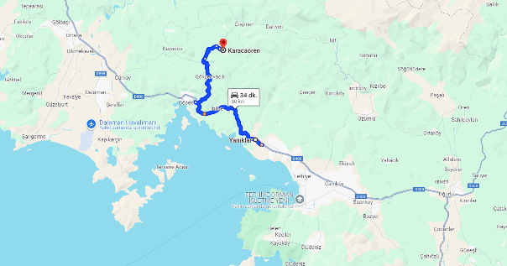

19:30 Depart to Fethiye

20:00 End of day