Regional Capacity Building Workshop *for NWFPs in Eastern Europe, Central Asia and Caucasus*

8-11 October 2024

## Venue

The Workshop will be organised at Fethiye Ömer Özen Training Centre owned by the General Directorate of Forest (OGM).

**Full Address:** Tuzla, İnönü Blv. No:3, 48300 Fethiye/Muğla/Türkiye

**For Contact:** +902526141086

The Training Center is about 50 km away from Dalaman İnternational Airport. Dalaman Airport (IATA: DLM, ICAO: LTBS) is an international airport and one of three serving southwest Türkiye. The old terminal is used for domestic flights and the new terminal is for international flights. Flights are available to and from over 120 destinations, across the rest of Türkiye, Europe, North Africa and the Middle East.

Web Page of Dalaman Airport: <https://www.dalamanairport.aero/en>

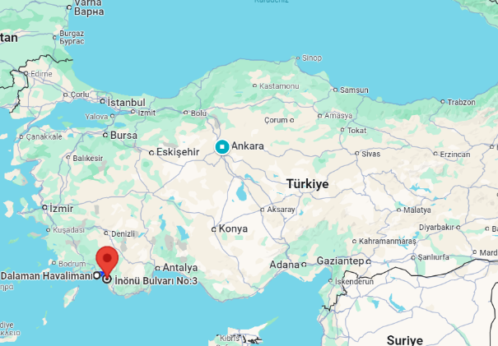

Detailed information regarding the airport transfers (from the airport to the hotel and vice-a-versa) can be found in the info note.

